Name_________________________ Teacher______________________

YEAR 9 NEAP ENGLISH
SEMESTER 2 TASK 2: Heroes

Sub-Strands  Literature  Responding to Literature:  Explore and reflect on personal understanding of the world and significant human experience gained from interpreting various representations of life matters in texts (ACELT1635) | Literacy  Creating Literature:  Create literary texts, including hybrid texts, that innovate on aspects of other texts, for example by using parody, allusion and appropriation (ACELT1773) | Language  Expressing and developing ideas:  Analyse and explain the use of symbols, icons and myth in still and moving images and how these augment meaning (ACELA1560)

Task 2 – Create a narrative of between 500-800 words that explores a section of the hero’s journey.

Process:
- Brainstorm a character who has, or will grow to have heroic qualities.
- Identify the section of the hero’s journey that your character will undertake.
- Draft your creative piece and finalise your good copy.

Hand in:
- Planning
- Drafts
- Good hand written copy

Assessment will be based on: Writing and creating
Responding to Literature:  Explore and reflect on personal understanding of the world and significant human experience gained from interpreting various representations of life matters in texts (ACELT1635) | Creating literature  Create literary texts, including hybrid texts, that innovate on aspects of other texts, for example by using parody, allusion and appropriation (ACELT1773)

LEARNING INTENTION | SUCCESS CRITERIA
Skills: Write in correct sentence structure and paragraphs.
Knowledge: (Content)
Understand what narrative conventions are.
Understanding: (Process)
How the use of narrative conventions affects readers’ responses.

Comments:

Assessment Criteria:
Writing:
 | A  Excellent achievement  80-100 | B  High achievement  65-79 | C  Satisfactory achievement  50-64
Language features | Makes a range of effective creative language choices in an imaginative text, including the use of descriptive and figurative language, to enhance meaning and reader engagement. | Makes a range of creative language choices in an imaginative text to influence reader response, e.g. uses emotive language to elicit sympathy. | Uses relevant, but often clichéd figurative language in an imaginative text.
Text structure | Creates an engaging imaginative text that develops own ideas and/or that accurately replicates the language and style of other texts. | Creates an imaginative text that presents own ideas and/or replicates some aspects of the language or style of other texts. | Creates an imaginative text that includes some ideas and language features of other texts.
Editing | Consistently uses a range of editing strategies to demonstrate control over sequencing of ideas, selection of vocabulary, spelling and punctuation. | Monitors and edits own work effectively for accuracy of spelling and punctuation and to achieve specific effects. | Reviews and edits own work to improve paragraphing, vocabulary and/or sentence structure.

Score:_____________

Writing: self-assessment checklist (complete before submission) Narrogin SHS
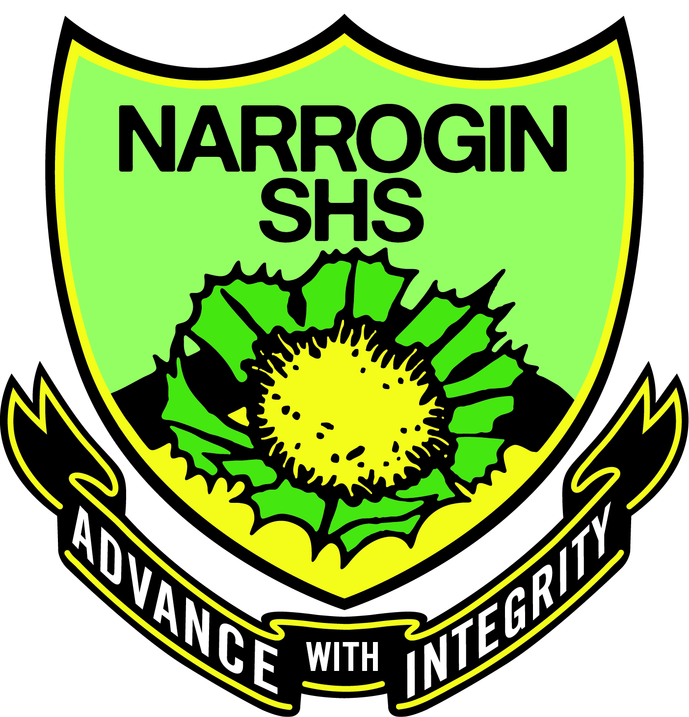 Name__________________________________________________ Year_______
AUDIENCE AND PRESENTATION | PUNCTUATION | CAPITALISATION | SPELLING AND VOCABULARY | IDEAS
⃝ My handwriting is  legible and any typed copies have no typing errors. | ⃝ I have used a full stop at the end of each sentence. | ⃝ I have used capital letters for the first word of each sentence. | ⃝ I have used the dictionary to spell the words I don’t know. | ⃝ I have used brainstorming and planning to organise my ideas.
⃝ I have written the title, my name and the date on my work. | ⃝ I have used commas between words in a list. | ⃝ I have used capitals for proper nouns (the names of people, places and the days of the week). | ⃝ I have used the correct terminology for this topic. | ⃝ I have acted on suggestions from the teacher.
⃝ My sentences are complete, make sense and use the key words from the question. | ⃝ I have used apostrophes to show contraction and possession. | ⃝ I have capitalised the pronoun ‘I’. | ⃝ I have used the correct homophones within my sentences:  your/you’re  there/their/they’re  allowed/aloud | ⃝ Each paragraph only has one main idea. My ideas are in a logical order.
⃝ I have attempted all questions and presented them in the correct order | ⃝ I have used a question mark after a question. | ⃝ I have written the main body of the text using lower case letters. | ⃝ There is evidence of editing on my drafts. | ⃝ I have used linking words to connect my ideas.

I have carefully checked all of the above before submitting this piece of work.

Signature: _________________________________________ Date: / / 2017

REFLECTION
What I need to improve on: | STRENGTHS: | WHAT I ENJOYED: | SPELLING WORDS: Write out the correct word three times
SELF REFLECTION WITH TEACHER | WHAT I DID WELL: | AREAS TO WORK ON IN MY NEXT ASSIGNMENT: | GRAMMAR: Write out the correct grammar rule

